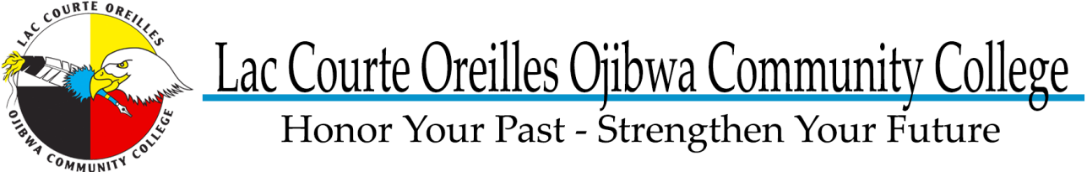

Work Based Learning Program Application
- Please Print

LCOOCC Student ID #: | Gender: M F
Name: | Date of Birth:
Address: | SS#
Telephone: | Message Phone:

- Which LCOOCC Program are you enrolled (check all that apply):

Associates Of Arts (AA) |  | One-Year Certificate
- Early Childhood Education |  | - AODA
- Human Services |  | - Native American Art
- Liberal Arts |  | - Office Support Specialist
- Native American Studies |  | - Native American Tribal Management
- Native American Studies Language |  | Specialized Certificate
Associates of Science (AS) |  | - Native American Studies Language
- Small Business Management |  | - Nursing Assistant
- Pre-Nursing |  | - Personal Care Working
- Science |  | Other Program
Associates of Applied Science (AAS) |  | - GED/HSED (General Education Degree/High School Equivalency Degree)
- Accounting |  | - Non-Degree
- Agriculture and Natural Resources |  | - Undecided
 |  | - Other Please Print:

- How can the WBL assist you best in achieving your goals

- Work Based Learning Internship (you need Student Internship Application, Resume, Cover Letter, current LCOOCC unofficial transcripts and current LCOOCC course schedule)
- Testing fees (you need this application and official supportive documents from the testing center detailing the fee)
- Attending a seminar, workshop, or training (you need this application and supportive documents that details the fees associated with the event)
- School related supplies (you need this application)
- Work related supplies (you need this application)
- Transportation (you need this application and weekly attendance sheet)
- Other (you need this application and other supportive documents for your request)

- Do you plan attending a four-year college or university after you gradate from LCOOCC? Yes No
- If so, do you want help with planning to transfer? Yes No

- Demographic information required by funding agency, please check all that apply:

- American Indian/Alaskan Native
- Asian
- Black/African American
- Hispanic
- Pacific Islander/Hawaiian
- White

- Divorced
- Legally Separated
- Married
- Separated
- Single
- Widowed

- A ‘barrier’ is something that makes it hard for you to get and keep either a job or to go to school/college. Please check all that apply:
- Age | - Income at or below the poverty level
- Child Care | - Need-based student financial assistance
- Family Health | - Other need-based financial assistant
- Personal Health | - Tribal General Assistance
- Self-confidence | - W2/TANF (Temporary Assistance to Needy Families)
- Program Entry Requirements | - WIA (Work Force Investment Act
- Scheduling | - Single Parent
- Language | - Limited English Proficiency
- School Expenses | - Academically Disadvantaged
- Job Search Expense | - Economically Disadvantaged
- Relocation | - Incarcerated
- Transportation | - Non-traditional Occupation
- Overqualified | - Displaced Homemaker
- Under Qualified | - Other (not listed):
- DVR client | - _________________

- Highest Grade Completed as of today: __________________________________________________________
- If you are applying for an Internship you must set date and time for a one-hour career coaching/career counseling meeting with WBL Program Coordinator, follow up meetings optional. If you’re not applying for an internship, but still would like career coaching or career counseling assistance, you may still sign up for a career coaching/career counseling meeting:
  - Date:____________________________________________________ Time:_____________________
  - Follow up meeting(s): Yes No Dates/Times: _______________________________________
With acceptance into the WBL program I give my consent for the WBL program staff to access and retain copy of information related to my academic career at LCOOCC. This permission extends to course schedule, grades, transcripts, attendance and participation in all LCOOCC courses in which I am enrolled.

Signature Date

Parent/Guardian Signature (if applicant is under 18 years of age) Date

