How to Find and Add Courses on Canvas
Step 1: Go to www.lco.edu
- Click “CANVAS” tab (top right corner of screen)

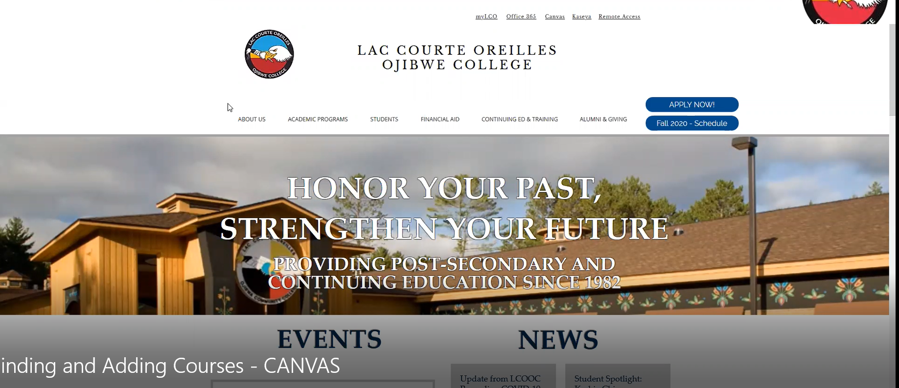

Step 2: Log into CANVAS using your @lco.edu email address and password.
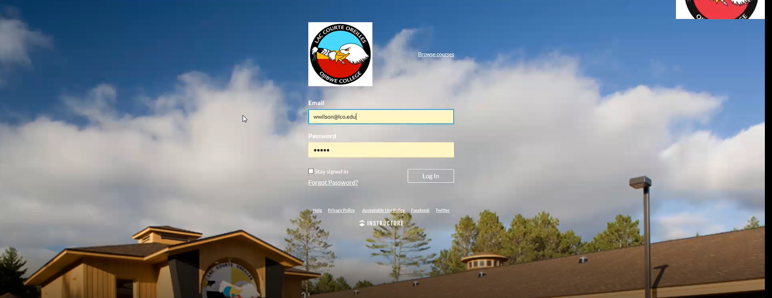

Step 3: Select “Courses” on left hand side of dashboard-
- Select “All Courses” (bottom of new menu)
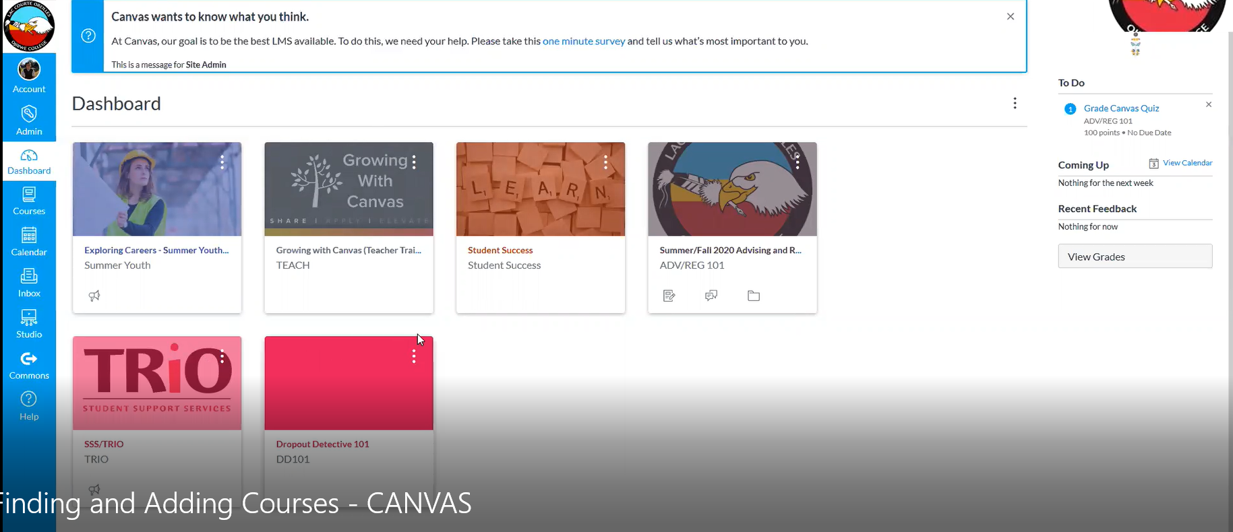
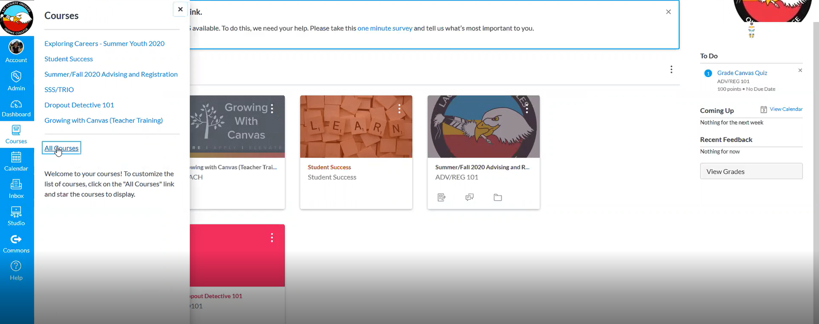

Step 4: Click “Browse More Courses”
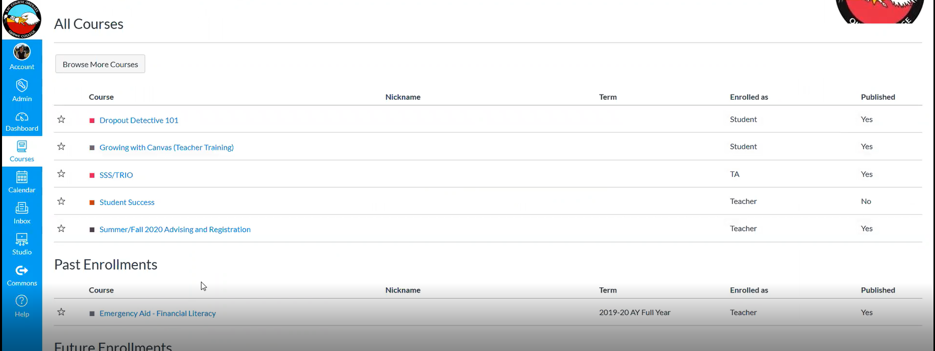

Step 5: Find and Join Courses
- Option 1: Search for Courses (Name, Code, etc.)
- Option 2: Select “Next” to Browse Courses
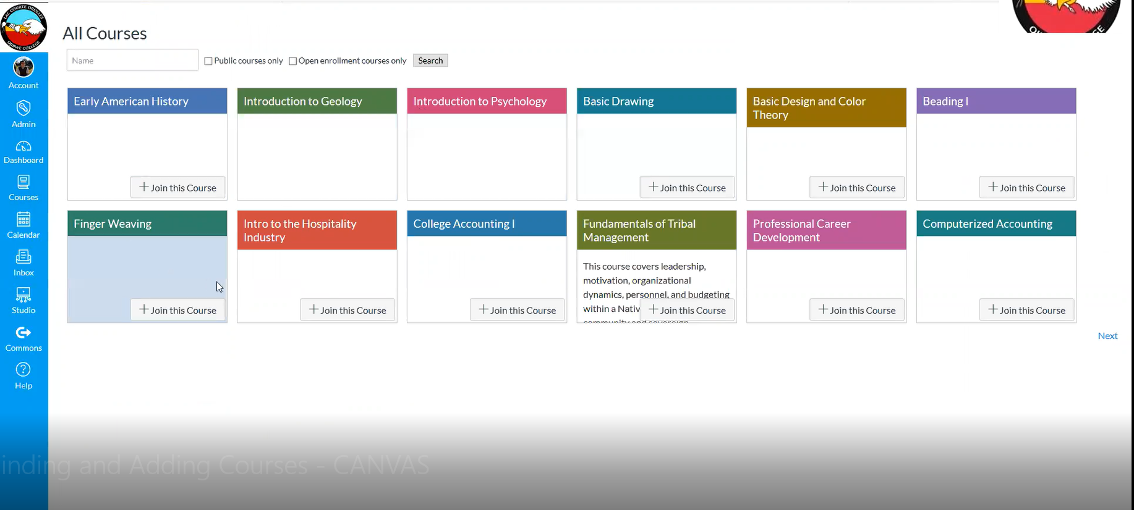

Lac Courte Oreilles Ojibwe College is always here to help- if you need additional assistance please contact Wes Wilson – Perkins/Project Success Coordinator at wwilson@lco.edu or (920)-212-7555.

